

Writing A Technical Report(Title)

ME 420 Mechanical Engineering Individual Research Project

Semester 8 : November 2023

By

A.B.C.Karunaratne (E/17/xxx)

This report is submitted for the completion of the requirements of the course ME 420 which is offered for the Degree of Bachelor of the Science of Engineering (B.Sc. Eng) of the University of Peradeniya

Department of mechanical Engineering
Faculty of Engineering
University of Peradeniya
Sri Lanka

Writing A Technical Report

by

A.B.C.Karunaratne

Supervised by

Dr. D.H.S.Maithripala,

Declaration

I declare that this report does not incorporate, without acknowledgement, any material previously submitted for any other Degree or Diploma to the best of my knowledge and belief, it does not contain any material previously published or written by another person or myself except where due references are made. It has not been accepted for any other course and is not being concurrently submitted to any other person.

Signature of candidate Date:......../......./........

...............................................
Name of candidate

....................................................

Countersigned by:
Signature of supervisor Date: ......../........./.........

..................................................
Name of Supervisor

.....................................................

Writing A Technical Report

Summary
The Abstract is extremely important because it helps readers decide what to read and what to pass over. The idea of the Abstract is to give readers an honest evaluation of the report's content, so they can quickly judge whether they should spend their valuable time reading the entire report. This section should give a true, brief description of the report's content. The most important purpose of the Abstract is to allow somebody to get a quick picture of the report's content and make a judgment.
Since an Abstract is a brief summary of your report, its length corresponds with the report's length. So, for example, if your report is eight pages long, you shouldn't use more than 150 words in the Abstract. Generally, Abstracts define the report's purpose and content.
http://writing.colostate.edu/guides/documents/ce-trpt/pop3c.cfm
Abstract vs. Summary?

- Technical report = Summary
- What does the report contain?
- Purpose
- Scope
- Major issues
- Main conclusions
- 1 page (or less)
- Concise, does not refer to specific parts of report

- Scientific report = Abstract
- Synopsis of information in report
- Problem
- Main results
- Main conclusions
- 200 words or less (1 paragraph)
- Strictly concise and condensed

http://www.cse.yorku.ca (York University Canada)

http://www.cse.yorku.ca/course_archive/2002-03/F/ENG1000/Eng1000_Tech_Reports.pdf

Nomenclature

A area m²
B bore m
x quality

Subscripts

amb ambient
i in

Greek symbols
η efficiency

Writing A Technical Report

1 Introduction 8
1.1 Preliminary pages 8
1.2 Main texts 8
2 How you use this template 10
2.1 Sub heading under 1 introduction 10
2.2 Sub heading 2 under 1 introduction 10
2.3 Sub heading 3 under 1 introduction 10
2.3.1 Sub heading1under sub heading 3 10
2.3.1.1 Sub heading under, above subheading 10
3 General Content 11
3.1 Example 1 11
3.2 Example 2 12
4 References 13
4.1 Examples of reference listings 14
4.2 Parenthetical citations 16
5 Plagiarism 18

Introduction

Preliminary pages
In this template, preliminary pages of a technical report are shown. The pages are numbered in Roman letters. Content page can be automatically updated (Right click on the mouse and then select update the field).
- Title page
- Declaration
- Summary
- Acknowledgements
- Nomenclature
- Content

Main texts
The formal numbering (from numbers 1 is started here).
- Introduction
- Background – History, location, methodology, etc
- Results
- Discussion of results
- Conclusions and recommendation
- List of references

How you use this template
It is highly advisable you to look this document carefully. You can fill the preliminary pages in this template. Do not change anything in the content page. Just after the content page, start writing the report. For example your first title is introduction. Type introduction and select it. Then go to the top of the page and select the style as heading 1. Then it will be automatically adjust the font size and spacing of the body texts. Then, just enter you will write the texts under introduction. You may have any number of headings under introduction. Just type the title and select as heading 2, if it is under introduction part.

Sub heading under 1 introduction
This is selected as heading 2. After selecting it as heading 2, then enter. Automatically it will adjust the spacing.

Sub heading 2 under 1 introduction
This is selected as heading 2

Sub heading 3 under 1 introduction
This is select as heading 2. You may have headings under headings 3.

Sub heading1under sub heading 3
Then you select it as heading 3.

Sub heading under, above subheading
This is called heading 4…. So on. Not advisable to go for more sub headings.

General Content
- No table or figure should be included if it is not specifically referenced in the text (i.e., at least “is shown in Figure 1 …” or “Table 1 summarizes…”, etc.)
- When referring to a table or figure, introduce it first.
- Figure captions usually go below the figure (not the MS XL default), and table titles go above
- SPELL CHECK!! PROOF READ FOR GRAMMAR!! If English is not your best subject or first language, have a friend read it too to help readability – if reader gets distracted or confused by poor grammar/spelling, report is very difficult to follow and intent is wasted
- Capitals – use when starting a new line or sentence, not within a sentence unless a proper name (e.g., “Engineering” is not a proper name when referring to the profession (no capitals), but is when referring to, say, a department (capitalize))
- Use colons to introduce a list, semi-colons to separate list items, and a period at the end – unless points are stand-alone sentences in which case all end with periods.
- No paragraph indentation used in technical reports – blank line separating paragraphs, full justify
- Excessive data/info should be placed in an Appendix so that the reader is not overwhelmed with useless information
- Write in third person (no I, We, You, etc.), use formal language (no contractions, slang, etc.)

Example 1
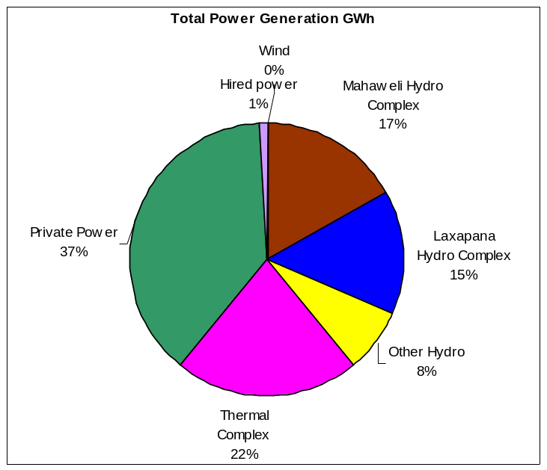
Fig.1. Hydro electricity contribution in the year 2009
This example is shown how a figure caption is placed in a report. Hydro electricity contribution in the year 2009 is shown in Fig. 1.

Example 2
Table 1: Bearing temperature limits
Bearing Type | Temperature / deg C (Alarm)
Bearing Type | Metal | Oil
Upper Guide Bearing (UGB)  Lower Guide Bearing (LGB)  Thrust Bearing (THB)  Turbine Guide Bearing (TGB) | 85  85  85  75 | 70  70  70  70

Typical acceptable bearing temperatures of a vertical shaft hydropower turbine are shown in Table 1.

Acknowledgments
This is to thank the people who helped for this work. Your supervisor, technicians whoever helped you during the work is thanked.

References
Whenever you cite information (this includes graphics) from another source, you must credit the source in your References. Always check with your instructor to determine which reference style to use.
- REFERENCE YOUR PATENT!! Include correct patent number (and indicate US patent – there are many countries)
- Ttechnical reports do not use a bibliography (list of sources used to draw info, items not necessarily specifically referenced),rather they have a references section where the summarize the references cited in the main text (specific references)
- References uncited in the text should not be included as sources! If a source is used, reference it properly
- Internet references should cite the page title, HTML ref., page author (or company), date visited, etc.

Examples of reference listings
Kosman, Josh. "The Rest of the Best." Civil Engineering, July 1994, 44-48.
Newhouse, Elizabeth L., ed. The Builders: Marvels of Engineering. Washing ton D.C.: The Book
Division, National Geographic Society, 1992, 50, 74-5.

- Books one author
McMillan, Terry. Waiting to Exhale. New York: Pocket Books, 1995.
- Books two or three authors
Shain, Yossi, and Juan J. Linz. Between States: Interim Governments and Democratic Transi tions. New York: Cambridge UP, 1995.
- More than three authors
Talmadge, John E., et al. The Rhetoric Reader. Chicago: Scott, 1962.
- Society, Association, or Institution As Corporate Author
American Red Cross. American Red Cross First Aid Textbook. Garden City, NY: Doubleday,
1971.
- Articles - Scholarly Journals with Continuous Pagination
Mosca , Joseph B., and Steven Pressman. "Unions in the 21st Century." Public Personnel
Management 24 (1995): 159-166.
- Articles - Scholarly Journals That Page Each Issue Separately
Ogburg, Charlton, Jr. "The Motor vs. America." American Heritage 21.4 (1970): 104-10.
- Monthly Magazines
Keller, Kathryn. "Waiting to Exhale." Vogue July 1992: 82.
- Weekly Magazine
Milliot, Jim. "Salary Survey: In Publishing, the Money's in Management." Publishers Weekly
31 July 1995: 55-58.
- Weekly Magazine, No Author Given
"Japan in Search of Japan." Newsweek 25 Nov. 1968: 52-54.
- Newspaper
Hechinger, Fred U. "Schools vs. Riots." New York Times 30 July 1967, sec 4:7.
ELECTRONIC PUBLICATIONS
Citations should include information about the print and electronic publications and the access information (URL, date of access).
E-Journal Collections (Article in a scholarly journal)
Danner, Bruce. "Speaking Daggers." Shakespeare Quarterly 51.4 (2003): 29-62. Project Muse.3Sept.2003<http://muse.jhu.edu/journals/shakespeare_quarterly/v054/54. 1danner.html>.
- Newspaper (Article in a newspaper or on a newswire)
Gootman, Elissa. "In Gamble, New York Schools Pay to Get Parents Involved." New York
Times on the Web 30 Aug. 2003. 3 Sept. 2003 <http://www.nytimes.com/2003/08/30/nyregion/30PARE.html>.
- Websites (Entire Internet Sites)
CNN.com. 2003. Cable News Network. 4 Sept. 2003 <http://www.cnn.com>.

Parenthetical citations
- Author's Name in Text
Machiavelli believed that "the ends justify the means" (1240).
- Author's Name in a Reference
There are many ways to argue this point (Walker 175).
- Authors' Names in Text
Many, like Lindsay and Crouse (90-100), disagree with him.
- Authors' Names in Reference
Many disagree with him (e.g., Lindsay and Crouse 90-100).
- Citing Volume & Page Numbers of a Multi-Volume Work
Jones does not see this connection (2:10).
- Citing Part of an Article or Book
Morrison's theory of the effect of prayer in school brings up a lot of questions (10, 17-23).
- Citing a Work Listed by Title
The article expressed how far reaching the Internet is in one's life ("Political Campaigns" 98).
- Citing a Work by a Corporate Author
The American Library Association has always fought for an individual's right to access information (16).
http://www.uwp.edu/departments/library/guides/mla.htm

Plagiarism

Plagiarism is the representation of another person's ideas or writing as one's own.
 The most obvious form … is the presentation of all or part of another person's published work as something one has written.
 Paraphrasing another's writing without proper acknowledgement may also be considered plagiarism.
 It is also a violation of academic honesty to represent another's artistic or technical work or creation as one's own.
 (i.e., these standards also apply to the creation and presentation of music, drawings, designs, dance, photography and other artistic and technical works)
 This is not to say that students should not use the work of others with the proper acknowledgement. Don’t plagiarize under ANY circumstances. (no copying from other sources)
 If you decide to paraphrase another author, even a little, REFERENCE the WORK!! (use footnotes, subscripts or numbers attached to References Section)
 Plagiarism could END your academic or professional career in some circumstances.
 As ENGINEERS, you must maintain the highest moral and ethical standards – breach of this trust may place public lives in jeopardy, hence there is NO

http://www.cse.yorku.ca/course_archive/2002-03/F/ENG1000/Eng1000_Tech_Reports.pdf

